Open
Woman Within
Circle

What is an Open Woman Within® Circle? | In our culture, there’s little time or support for women to express their innermost truth. A Circle lets you experience freedom from the daily world. Take 2 hours to introduce yourself to the experience of sitting in a Woman Within Circle, where you can open your heart and connect with yourself – & other accepting women.
What will I get from it? | - A chance to experience sitting in a Woman Within Circle and an ability to come to know its benefits  - Learn about your options for joining a Woman Within Circle or taking Woman Within Circle Training
Who can attend? | Any woman over 18 may attend. Completion of the Woman Within Weekend is not necessary to attend. Women who attend can then sign up for Woman Within Circle Training. Please see the separate flyer for more details about that.
Who will lead it? | Leader’s Name Here (something about the Leader here)
When and where? | - Date and Time Here  - Location Here
How much will it cost? | It’s free.
Any prerequisites? | None. Completion of the Woman Within Weekend is recommended but not required.
How do I RSVP?  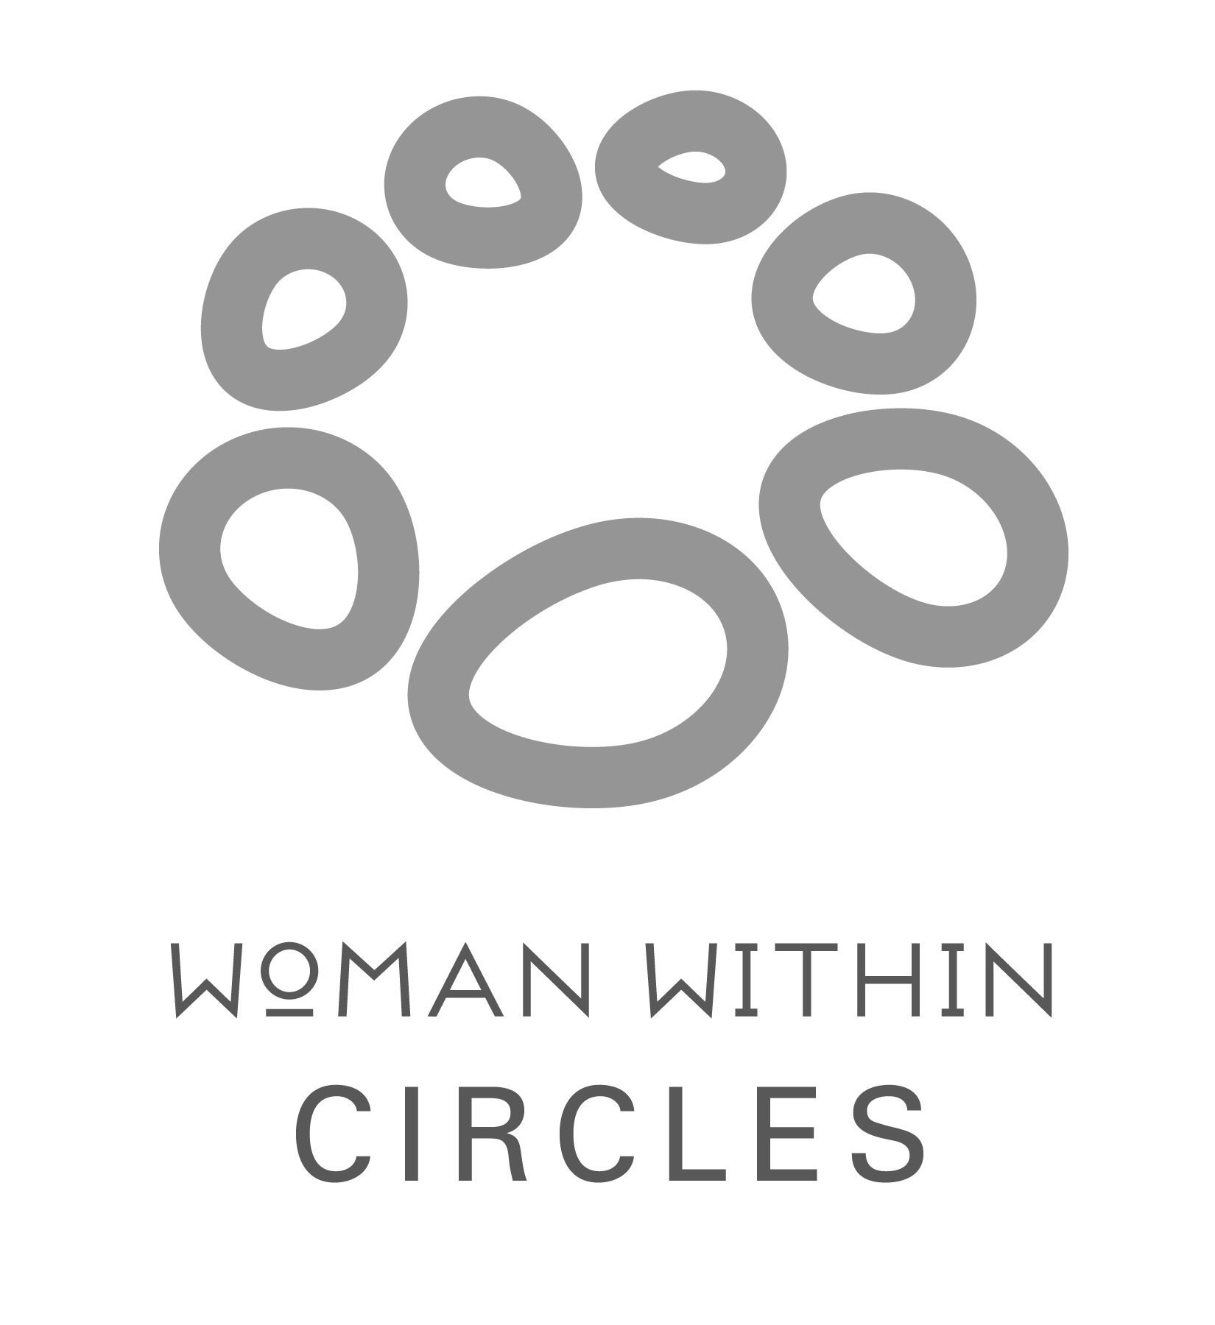 | Please contact Contact Name at contact email address to save your place!  Circle Co-ordinator - Annie Bate  circles@womanwithin.org.uk  www.womanwithin.org.uk

