Woman Within
Circle Training

What is Woman Within® Circle Training? | In our culture, there’s little time or support for women to express their innermost truth. A Circle is a safe, confidential place to speak, feel heard and to develop authentic connections with other women. Circle Training will teach you how you can benefit from being part of a Circle of women who gather regularly to offer acceptance and inspire change in one another.
What will I get from it? | - A new set of communication skills used in Woman Within Circles  - Effective tools and exercises that deepen connection and empower ourselves and others  - A community of women on a path of personal growth
Who can attend? | Any woman over 18 may attend. Completion of the Woman Within Weekend is not a prerequisite. Women who attend Circle Training can then sign up for Woman Within Circles. Please see the separate flyer for more details.
Who will lead it? | Leader’s Name Here (something about the Leader here)
When and where? | - Date and Time Here  - Location Here
How much will it cost? | Varies
Any prerequisites? | Check with regional representative
How do I RSVP?  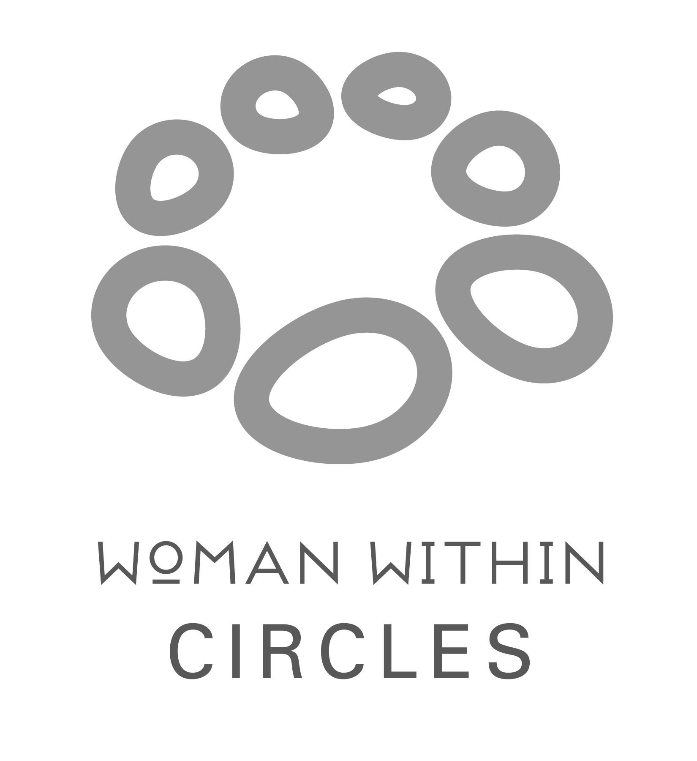 | Please register online at www.womanwithin.org.uk or email Annie on circles@womanwithin.org.uk

